In Tutorial 05 we will review best practices for improving WordPress Security, learn how to use the RDBMS phpMyAdmin to create tables, add table columns, and import and export MySQL databases and tables. We will continue learning about WordPress Custom plugins and write more advanced version of them. We will also introduce the concepts of versioning WordPress sites using GitHub. We will learn the techniques necessary to prepare our WordPress site so it can be safely copied to a GitHub repository. For PHP, we will review and practice-coding PHP using prewritten functions sizeof, gettype, strlen, trim, var_export, print, print_r, and var_dump.  
  
After WordPress we will continue our PHP education.  
We will work through PHP

Note: There is a tutorial template file to download, rename and submit to D2L. Tutorials are required.

Web host tools used in the Tutorial:  
(1) Shared Web Host SiteGround

(2) Pantheon as a Service (PaaS)   
 – Substitute for Shared web host for those with PaaS accounts.  
 - Pantheon users – Please install MySQL WorkBench on your local computer

(3) Cloud Web Host – Codeanywhere

Tutorial 05 Parts Index  
Part A – Getting started with this tutorial

Part B – Build WordPress sites on 3 Platforms   
Part C – Add content using the All-In-One WP Migration Plugin  
Part D – Introducing the RDBMS phpMyAdmin  
Part E – Review Best Practices for Improving WordPress Security  
Part F – WordPress Custom Plugins Continued  
Part G – Introducing WordPress GitHub Workflow – versioning WP with GitHub  
Part H– PHP Prewritten functions   
 *sizeof, gettype, strlen, trim, var_export, print, print_r, and var_dump*   
Part I – Questions or problems with this tutorial?

**Part A – Getting started with this tutorial**

1. Download the Tutorial 05 assets zip file, template and instruction files from D2L.
2. Expand the asset file on your computer
3. Rename the template file by adding your full name to the front of the template file name.
4. Open the renamed template file for editing.
5. Go to **Part A** and add your name and contact info.

Part B - Create a WordPress CMS on Shared Web Host or Pantheon

Create a WordPress CMS on your shared web host (or Pantheon PaaS) account.

(B.1) If using a Share web host account:

* 1. **Software setup:**
     1. Protocol: http:
     2. Domain: Select the default domain
     3. In Directory: “**tutorial05**” (***all lower case***)
  2. **Site Settings:**

1. Site Name: [**Your First Name]** - **Tutorial 05**
   1. Substitute your first name for **[Your First Name]**
2. Site Description: **Tutorial 05 WordPress**
3. **Enable Multisite (WPMU): Do not enable Multisite** 
   1. **Admin Account:**
4. **Admin Username:** select default or create one
5. **Admin Password:** select default or create one
6. **Admin Email:** Accept default or add one
   1. Only use default email if you established an admin email on your web host
   2. **Choose Language:** - **Set language to the default of English**
   3. **Select Plugins**
      1. **Limit Login Attempts – Uncheck this option**
      2. **Classic Editor – Do not (check) this option**
   4. Easy setup:
      1. WordPress Starter – Uncheck this option *We do not want this!
   5. Advanced Options:
      1. Database Name: select default
      2. Table Prefix: select default
      3. Do not change the Backup location
   6. ***Press the Install button and wait for confirmation page to display***
   7. Open the Tutorial 05 Template and record following information in Part B [B1]

**-OR, if using Parthenon instead of a shared web host-**

**(B.2) If using Pantheon:**

1. Create Your Pantheon Site
   * + Name Your Pantheon Site: **[Your First Name] – Tutorial 05 PA**
     + Choose an Organization for the Site: Set to None
2. Choose Your CMS: Select the Deploy button for WordPress
3. Select the "Visit your Pantheon Site Dashboard" button
4. Select the Install WordPress button
5. Configure your WordPress Site as follows:
   * + Language: English (United States)
     + Site Title: **[Your First Name] –Tutorial 05 PA**
     + Username: enter in a username
     + Password: use default or enter a strong password
     + Email: use your Pantheon login email
6. Press Install the WordPress site
7. ***Before you press the “Install WordPress” button***, open the Tutorial 05 Template and record following information in Part B [B.2]  
   PaaS WordPress site Admin username:   
   PaaS WordPress site Admin password:
8. ***Press the Install button and wait for confirmation***
9. Open the Tutorial 05 Template and record following information in Part B [B2]

***A Codeanywhere WordPress site is required for this tutorial:***

**(B.3) Build a Codeanywhere WP Site – Upgrade to version 5 & Edit Config files**

1. Open a web browser and navigate to the Codeanywhere website - <https://codeanywhere.com/>
2. Select the Login link
3. Login using your email and password – established in previous weeks tutorial
4. To create a new WordPress site, and a site container already exists, you must delete the container – our student accounts allow only 1 live container at a time
5. Create a new Connection > Container
6. Fill out the Connection Wizard container form
   1. Name: [your lower case initials]tutorial5ca
      1. All lowercase + no spaces (especial no spaces at the end)
   2. Choose a WordPress stack: **I use WordPress Ubuntu 14.03**
   3. Do not enable **Always on** – This wont work with our accounts
7. Be patient while Codeanywhere deploys your container server
   1. This may take a while
8. Select the link to access your web application over HTTPS protocol  
   - this loads the WordPress build script
9. Configure your WordPress Site as follows:
   1. Select English and continue
   2. Site Title: **[Your Initials] –Tutorial 05 CA**
   3. Username: enter your username – do not use the word admin
   4. Password: enter a strong password
   5. Email: use your Codeanywhere account email
   6. Search Engine Visibility – Select (check) Discourage indexing
10. Press the “Install WordPress” button and wait for confirmation
11. Upgrade the WP site to Version 5
12. Upgrade all the plugins
13. Upgrade all themes
14. Change the active theme to Twenty Twenty
15. Edit configuration files to fix the File Upload Max issue
    1. wp-config.php file
    2. .htaccess file
16. Close down the WordPress site and Restart the Container–Connection
17. Verify that the WordPress site is working
18. Open the Tutorial 05 Template and follow the instructions to add screen captures for Part B [B3]

**Part C –** Add Site Content by restoring from a site backup*Use the All-In-One WP Migration plugin and a [.wpress] site backup file.*

In this tutorial, we will add our content to our WordPress sites by importing them from an All-In-One migration (.wpress) backup file, provided in the Assets zip file.

The All-In-One (.wpress) backup file**:** student.sgedu.site-145614-428.wpress

The new WP site admin user login credentials are:  
**Admin username:** student

**Admin password:** xxx123!!!

The All-In-One backup file is about 10 - 11 MB in size.   
This should install on all 3 platforms.   
Before installing on the Codeanywhere platform, you must edit the   
[wp-config.php] and the [.htaccess] file and restart the connection–container. You should also close down the WordPress site, restart the container, and access the restarted WP site, on a new web browser tab.

If you fail to properly edit the edit [wp-config.php] and the [.htaccess] or restart the connection-container, you will see this error window when you try to import the .wpress file:

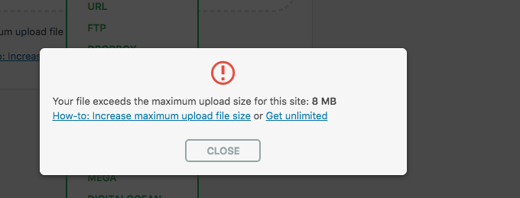

1. Install the All-In-One WP Migration plugin on all platform WordPress sites
2. Import The All-In-One (.wpress) backup file **[**student.sgedu.site-145614-428.wpress]
3. When the import completes, select   
   Dashboard > Settings >Permalink option
4. This will force you to login to the WordPress site
5. Use the new Admin username and password to login
   1. **Admin username:** student
   2. **Admin password:** xxx123!!!
6. **Select** Dashboard > Settings >Permalink and save the Permalink settings
7. **Review the new imported WordPress site. It should have** imported 7 images, 3 Pages, 3 Categories, 4 Tags, 3 Posts, and many Comments.

Open the Tutorial 05 Template and record following information in Parts C.1 - C.3

**Part D – Introduction to phpMyAdmin - RDBMS**

(A) Intro to PHP MyAdmin

1. Access phpMyAdmin on Shared Web Host - SiteGround
   1. Select the current WordPress MySQL Database
   2. Create a new table named wp_db_prefix_[person]
      1. Where the wp_db_prefix is your DB table prefix
   3. Create the Person table structure – add columns and set data types
      1. ID – INT – Auto Increment (AI) + Primary Key
      2. Name – VARCHAR 255
      3. Age - INT
      4. EyeColor – VARCHAR 10

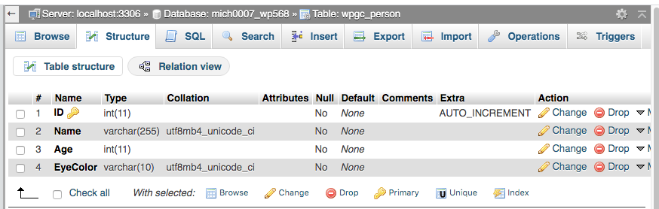

* 1. Add 4 Person table records
  2. Export the person table (export only the person table)
  3. Drop the person table
  4. Restore the person table by Importing (restore from the .sql export)

1. Demo Pantheon Database access via local MySQL Workbench
   1. Quick overview of MySQL Workbench
   2. Create a ne Person table on MySQL Workbench
   3. Edit the .sql backup file, change the DB prefix for import
   4. Import personx table from (.sql) export
2. Access phpMyAdmin on Codeanywhere
   1. Create a new Person table
   2. Add 4 Person table records
   3. Export the person table (export only the person table)
   4. Drop the person table
   5. DO NOT EDIT THE .SQL file – as I did in the tutorial
   6. Restore the person table by Importing (restore from the .sql export)

Open the Tutorial 05 Template and take screen captures for Part D.

**Part E – Improve WordPress site security**

1. Review WordPress security presentation and article.

Open the Tutorial 05 Template and answer questions about improving WordPress security for Part E.

**Part F – WordPress Custom Plugins Continued**

Review the Module 05 D2L Presentation on WP Custom Plugins

F.1 - SiteGround

1. On SiteGround - Create environment for a custom plugins
   1. Install, demo, and review the Posts reader custom plugin

F.2 – Pantheon (PaaS)

1. On Pantheon – create an environment for a custom Plugin using FileZilla
   1. Install, demo, and review the Posts reader custom plugin

F.3 - Codeanywhere

1. On Codeanywhere - Create environment for a custom plugins
   1. Install, demo, and review the Comments reader custom plugin

F.4 – Demo how to copy, rename and edit custom plugin files to query different DB tables. Posts Table Reader 🡪 Users Table Reader

Open the Tutorial 05 Template and take screen captures for Part F.

**Part G – WordPress GitHub Workflow – Introduction**

NOTE:   
Please review the presentation and video on how to fix the composer error before attempting this part. Some students are not experiencing the error. Those that do, will find the solution relativity easy to execute.   
**Presentation:** M05 - Tutorial - Part G - Codeanywhere Issue Fix  
**Video:** Tutorial 05 - Part G.A - Codeanywhere Issue Fix

1. Review the D2L Presentation on WordPress GitHub
2. Students Create your own GitHub Account
3. Work along as we demo how to configure a Codeanywhere WordPress site for versioning on GitHub [WordPress GitHub Workflow Part I]
4. Configure WordPress for GitHub storage
5. Establish a GitHub Repository
6. Backup and encrypt the WordPress Database
7. Push the WordPress files and encrypted MySQL database to the GitHub Repository (REPO)

Open the Tutorial 05 Template and take screen captures for Part G.

**Part H – PHP – Prewritten Functions**

**Testing PHP Programs using PHP Emulation Websites:**

* Online PHP test sites:
  + <http://phptester.net>
  + <http://sandbox.onlinephpfunctions.com/>
* How you test your script depends on which test site you use.
* **Each PHP emulation test site works slightly different**.

Please review the Module 05 presentations before attempting to answer the PHP questions.  
  
Please review and use the example PHP code located in the Module 05 PHP Examples section.   
Go to the Tutorial 05 Template file and answer the PHP questions for Part I.

**Part I – Questions or problems with this tutorial?**

Please review your template file.

**If you have questions or issues about this tutorial please contact the instructor immediately.**

**To get help, either submit an IRT, or make an appointment with the DePaul tutor or connect to BlueStar and make an appointment for an office hours appointment for help.  
If you find errors with this tutorial, please fill out a BRECT form and submit it to the instructor ASAP for Extra Credit points.**

Michael H Chase

Mobile: 847-878-6225

Office: 312-362-1352

Email: [mchase2@cdm.depaul.edu](mailto:mchase2@cdm.depaul.edu)

Make sure you added your name or initials to the front of the template file name and then submit the renamed and completed template to D2L for review and grading.   
If you prefer not to navigate by hand to the D2L dropbox, take advantage of the dropbox link in the current D2L Module Tutorial section. The D2L link will take you to the correct tutorial dropbox location.